1. Creating and Renaming Files/Directories

Create a directory named test_dir using mkdir.

Inside test_dir, create an empty file called example.txt.

Rename example.txt to renamed_example.txt using mv

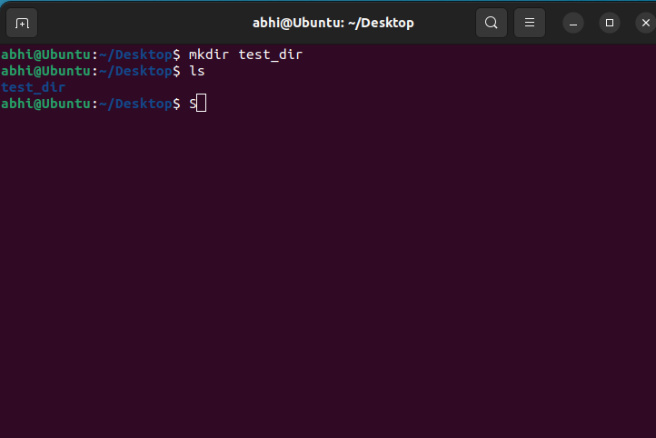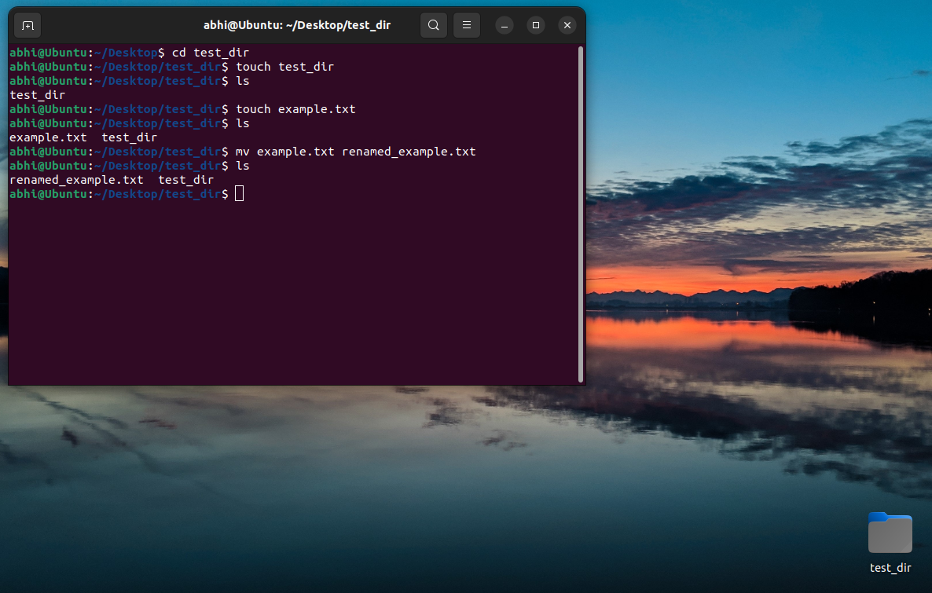

**Explanation:**

* mkdir test_dir: Creates a directory named test_dir.
* cd test_dir: Navigates into the test_dir directory.
* touch example.txt: Creates an empty file named example.txt.
* mv example.txt renamed_example.txt: Renames the file to renamed_example.txt

2. Viewing File Contents

Use cat to display the contents of /etc/passwd.

Display only the first 5 lines of /etc/passwd using head.

Display only the last 5 lines of /etc/passwd using tail.

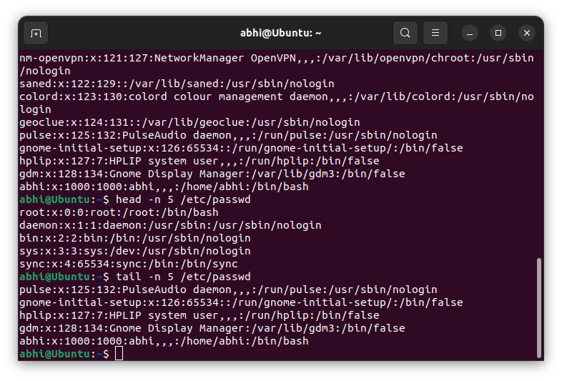



**Explanation**

* cat: Shows the full content of /etc/passwd.
* head -n 5: Displays the first 5 lines.
* tail -n 5: Displays the last 5 lines.

3.Searching for Patterns

Use grep to find all lines containing the word "root" in /etc/passwd.

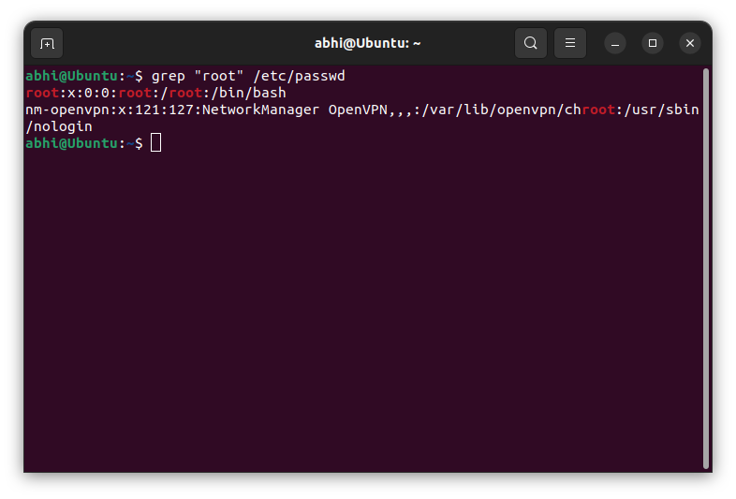

**Explanation**

* grep "root": Finds all lines containing the word "root"

4. Zipping and Unzipping

Compress the test_dir directory into a file named test_dir.zip using zip.

Unzip test_dir.zip into a new directory named unzipped_dir.

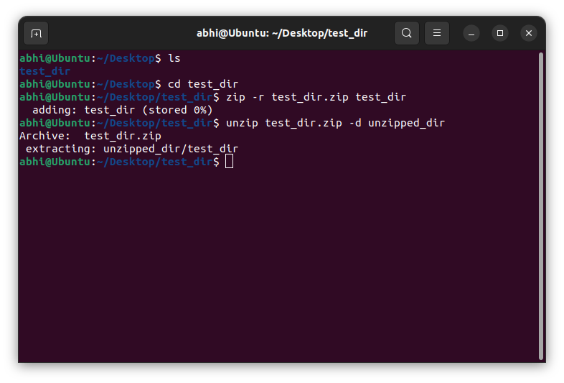

**Explanation**

* zip -r: Recursively compresses the directory.
* unzip: Extracts to a new directory named unzipped_dir

5. Downloading Files

Use wget to download a file from a URL (e.g., <https://example.com/sample.txt>).

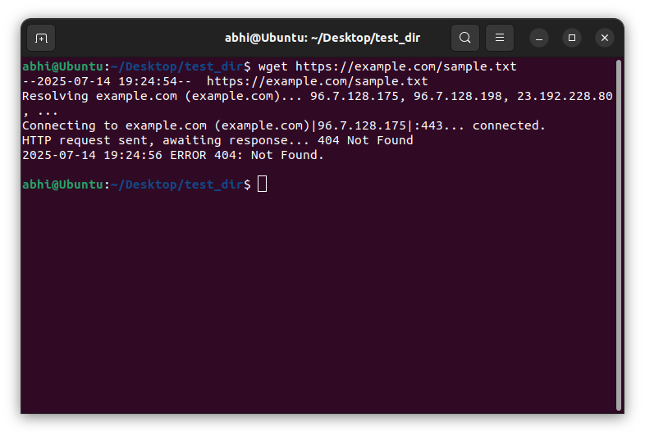

**Explanation**

* wget: Downloads files from the internet using the provided URL.

6. Changing Permissions

Create a file named secure.txt and change its permissions to read-only for everyone using chmod.

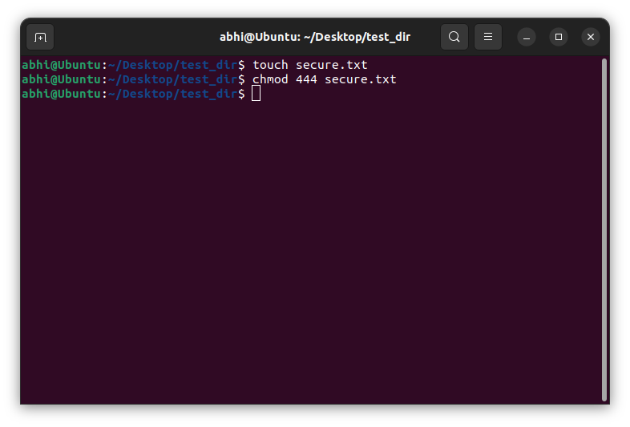

**Explanation**

* chmod 444: Sets file to **read-only** for owner, group, and others.

7. Working with Environment Variables

Use export to set a new environment variable called MY_VAR with the value "Hello, Linux!".

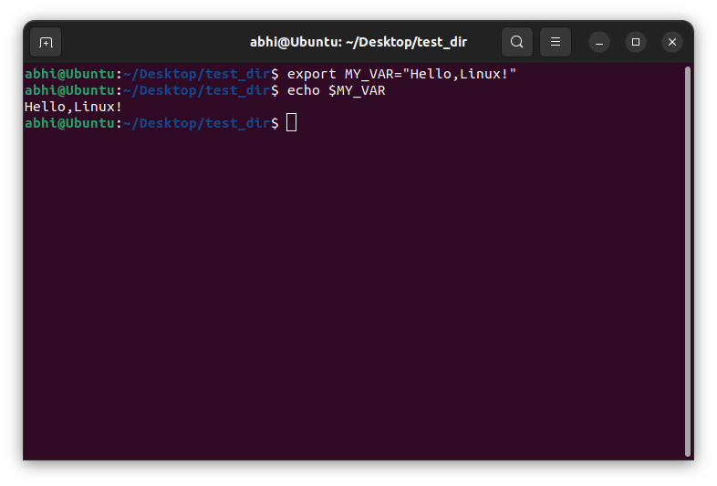

**Explanation**

* export: Sets an environment variable.
* echo $MY_VAR: Prints the variable’s value.